West Hull Ladies
RRC

August Newsletter
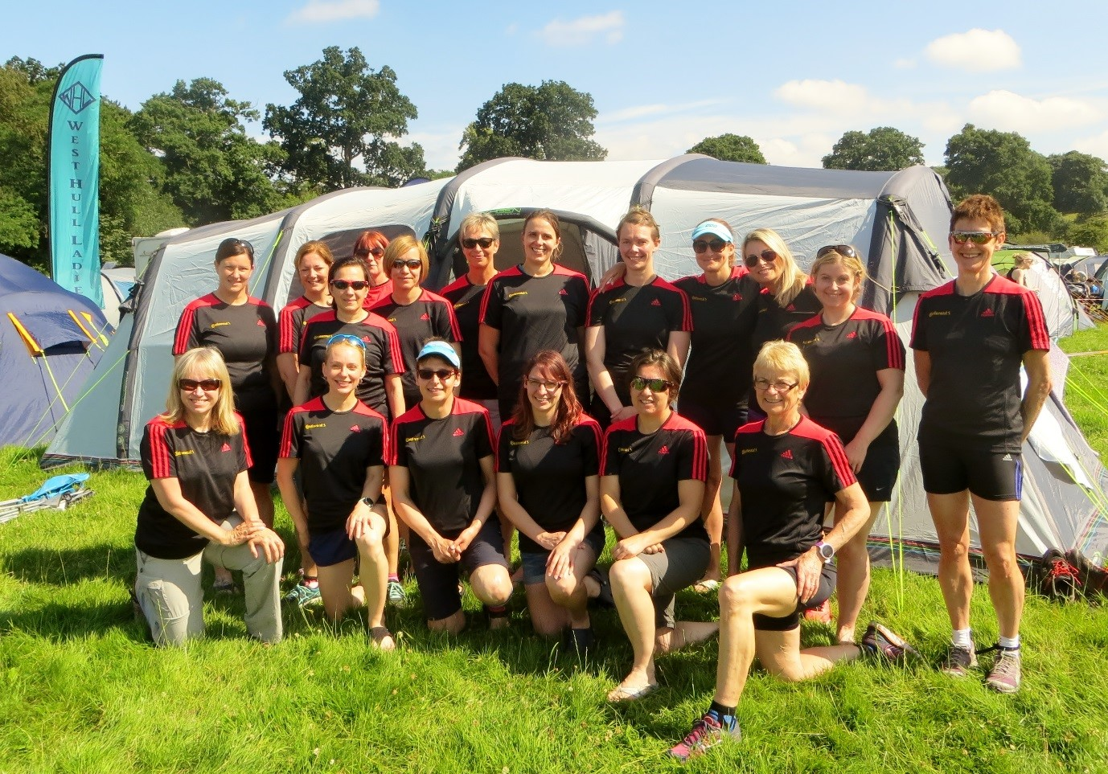
Karen, Andrea, Debbie, Sara, Rachel A, Jan D, Ros, Liz D, Jane, Rach, Sally, Amanda
Sarah JW, Shelley, Jill J, Zoe, Verity, Linda

18 Ladies ran: a solo, a pair and 3 teams of 5

Karen’s hubby was fantastic supporting us being our cabin boy.
Thank you for keeping the kettles on the boil.
Those cups of tea kept me going.
Amanda

West Hull Ladies
Committee Meeting Minutes
1st August 2016-08-04

Present - Jill, Amanda, Anna, Linda, Karen, Sandra, Shell

1. Apologies from Liz, Jan, Maria, Annette
2. Minutes of previous meeting accepted as accurate record
3. Matters arising a) Jill updated the Committee that she had spoken to Steve Holmes from City of Hull AC in relation to us supporting them in the organisation of an event in order for us to gain experience. Steve had suggested we help at the Winter League. Agreed we would do this. b) Agreed date for the talk “Tired of being tired” 17th October 7.30pm after Monday training. Action Amanda to continue. c) parkrun initiative held at East Park Saturday 30th July had been a huge success. All ladies were thanked for supporting this and especially Shell for organising.
4. Jill spoke about the success of Thunder Run and Endure and how we had to be organised as entries were becoming more difficult. We had to be in a position where we knew how many ladies wanted to enter. Action Jill to email ladies to ascertain level of interest for 2017.
5. Head Torches. It had been suggested that the Club purchase head torches for the use of members at the 24-hour events. After a discussion it was felt that ladies should provide their own but that we would have a supply of batteries. Agreed that the list Jill circulates prior to the event-advising ladies what to bring be amended to include this. Action Jill to update list.
6. Accounts - Linda produced up to date accounts. She was thanked for her hard work. Karen updated the Committee that we now had 76 members.
7. It was noted that Suzanne was representing GBR in the World Biathle Championships to be held in the USA in October. It was agreed that this was a fantastic achievement and that the Club should offer Suzanne a donation towards the cost of this. They expressed congratulations and good wishes to Suzanne. Action Jill to contact Suzanne.

Meet a Member : Caroline Bradbury

Age - 40

Member of WHL since – January 2016

What do you do when you’re not running? – When I’m not running I’m mum to my 3 year old boy Monty and I teach languages. When I can I also like to paint and bake and go hill walking, but raising a toddler whilst working full time has changed the amount of spare time I have available for all that!

How long have you been running? – I’ve been actually running (not pretend running!) since January when I joined the 025k course. At school the 1500 was my distance and I usually managed to blag a day off school as reserve on sports days, with the exception of the last year of school when I had to compete, but I didn’t keep it up and that stopped when I left school. 10 years ago I was encouraged to do the couch to 5k course with a friend with the goal of competing in a “10k fun run”, but running in very cheap trainers I injured my knee a few weeks in, and on the advice of a running friend decided to rest it ahead of running, so stopped all training and rested. Completely. The “10k fun run” turned out to be the Ferriby 10 – not fun, very gruelling, and for me very demoralising! I caused further damage to my knee and ended up walking most of it, being chivvied on to run by very impatient marshalls following me on the route as they were keen to get home. I think I crossed the line in agony and in tears, and even though I invested in some proper running shoes (which I’m using now as they stayed unworn and in pristine condition), up went the huge mental barrier to running that lasted until last year, when I dabbled in the couch to 5k course with some local mums. However we were way too soft on ourselves and after a few weeks of repeating the same stage that soon petered out.

Why did you start running? - Shelley and Annie S first brought the WHL 025k course to my attention as being friendly and supportive, and for me it was perfectly timed to get me in better shape to sport a posh dress for my 40th. When I was pregnant I used to walk one lap of the park run whilst my husband ran the full thing, so as well as getting in better shape for my 40th my goal was to complete 5k non-stop, which is something I’d never done before.

Favourite distance – probably 5k or 5 miles at the moment

Favourite bit of running kit – my running trousers from Simply Running. In all my other attempts at “running” I’d always be hoiking up my trousers as I ran, and I really appreciate a properly-fitted pair of trousers!

Any injuries? – I had to receive 6 weeks of physio in the end for my knee injury mentioned earlier. I was told it was fluid on the knee, but it was affecting my everyday life so I eventually went to the doctor’s to tackle it. Other than that I have had minor grumbles since running more regularly with WHL, but I have invested in a foam roller and have been much quicker to recognise a potential niggle, so so far (touch wood!), nothing too serious that I can’t manage myself.

Running goals? – I’d like to get to the stage where I really enjoy running and can run a 10k much more comfortably. I have the odd good run but most of them are still quite a slog for me. A few things have stopped me being able to come to the club as much recently so I need to get back to much more regular training, which I know will help.

Proudest moment running related or otherwise – I am really proud that since January, having had the goal of being able to run a park run non-stop, I have not just done that (I think I have done 3 now), but I have also completed 2 x 5 mile races and 2 x 10k races, and have surprised myself that I have been able to run those distances non stop too!

Best piece of advice you’ve received – that it gets easier after the first 10 minutes, and to use my arms to push me along faster when my energy levels are low at the end of a race!

Running alone or with friends? – with friends definitely. WHL has helped me develop the grit I needed to be able to complete runs on my own, but I don’t enjoy that as much, and the friendliness and support of this club is what has brought me to where I am now.

What keeps you motivated? – entering races keeps me motivated to keep up the training, but I’m definitely in better shape because of the running I’ve done this year, and nicer-fitting clothes is always a motivator!

Thunder Runners by Amanda

Liz D
Solo – 80K
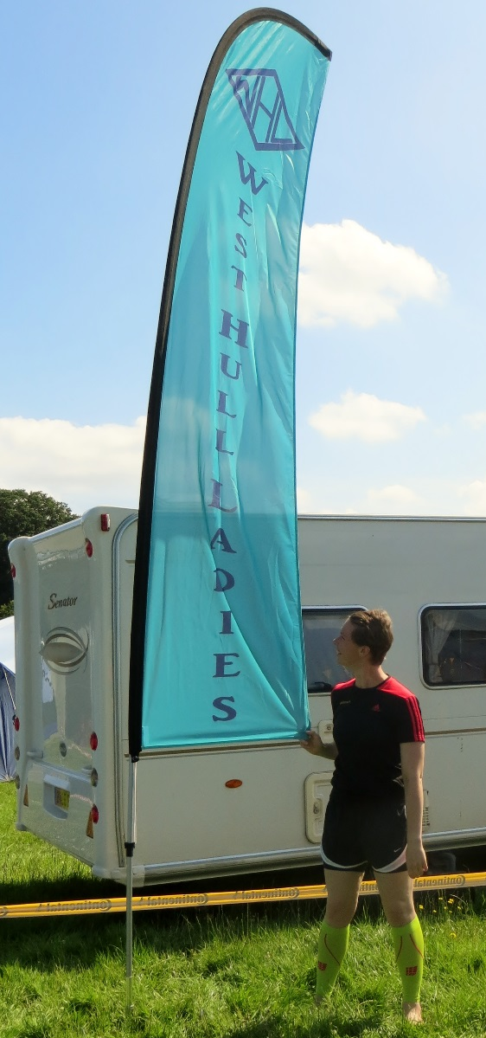
Barking Bonkers
Linda 90K - Rachel A, 100K
3rd Pair
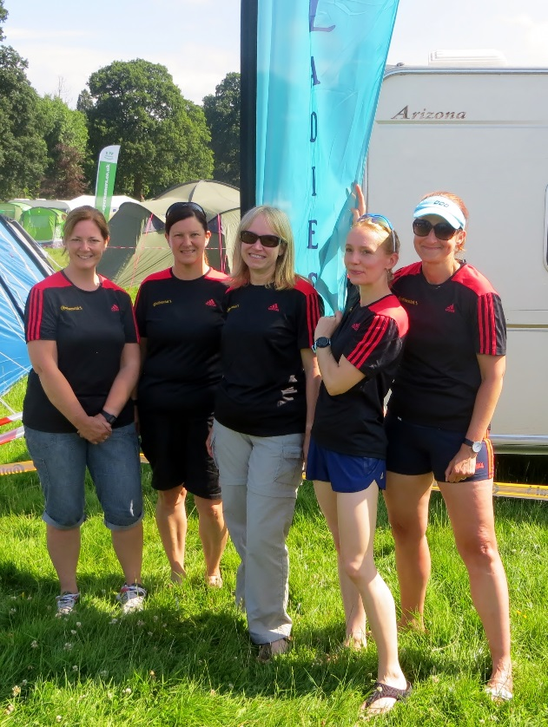

WTF – Where’s the Finish?

Andrea 30K
Karen S 40K,
Sarah JW 40K
Shelley 40K
Jane 40K
13th team out of 20

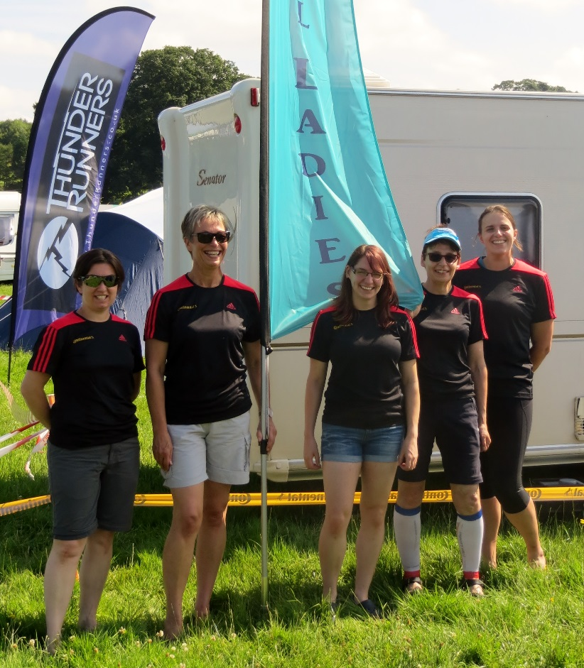

I’m a WHL Get me out of here!

Verity 40K,
Jan D 40K,
Zoe 50K,
Jill J 40K,
Ros 30K
12th team out of 20

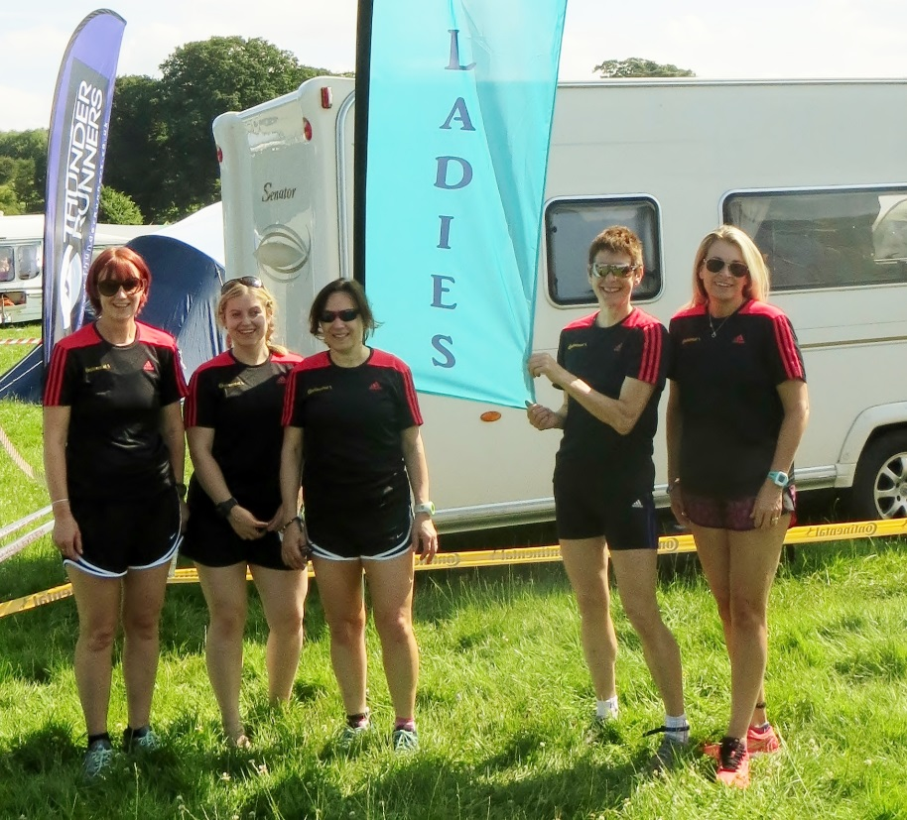

Da Do Run Run

Sara 50K
Sally 40K
Debbie 40K
Amanda 50K
Rach 50K
6th team out of 20

Thunder Run: Linda

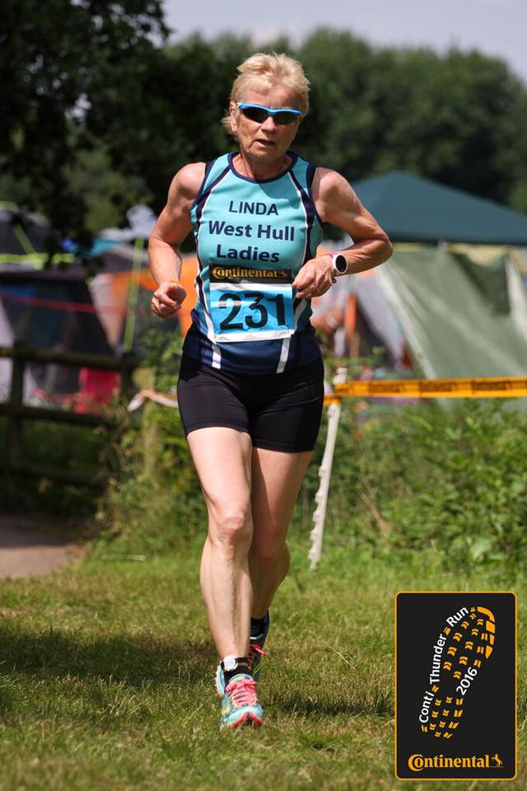
Last year Rachel Anderson and I ran in a pair at Thunder Run but due to having an injury and not feeling well we had to pull out, poor Rachel went on holiday a week or so later and had to have her appendix removed while abroad so this must have been niggling during that race.
We decided to give Thunder Run another go this year, both of us had been training for and competed in a marathon, her injury was ‘mended’ by Kris Lecher after giving her exercises to complete etc. We trained well during the year and stayed healthy, nearer the time we even managed a few off road ‘practices’ but only doing around 3 laps of a set course, we had to do so many more for the Thunder Run, could we do it?
After lots of planning with our other competitors within WHL that were competing in the fives and Liz Draper in a solo, Jill and I went and did a supermarket sweep and filled two trolleys of food and drink (not the alcoholic sort). That’s such good fun!
Jill, Liz, Zoe, Andrea, Shelly, Jane and Ros arrived Friday and set up base camp and what a fab position they got too, Sarah JW and I arrived later armed with beer (can you believe they sent us for beer, two WHL who don’t drink), still we got the right stuff in the end! The rest of the teams arrived Saturday morning.
Getting a bit nervous now, after having lots of conversations with Rachel and her devising running plans we decided that she would run the first leg, one lap, then I would run the second leg, one lap then after that we would do two laps each so the one not running could have a bit of a rest and eat, etc. The laps are 10k off road, through a couple of woods and grassy banks, very pretty and the sun was shining plus it was hot too.
The race starts at 12noon on Saturday and finishes 12noon on Sunday. Finally we were off, it was lovely to see so many WHL at the start of this event. All too soon it was my turn to take over from Rachel as she completed her first lap. I was so pleased to be on my way, nerves always get to me but once I start running I’m usually fine. I loved that first lap, it sure was hot but it was over before I knew it. We were trying to keep the laps slow as this course is all about endurance so we both managed lap 1 at 1hr 6mins and 1hr 7mins.
Then it was Rachel off for the first set of two laps. It was lovely to have a little break, a rest and something to eat and spend some time with our ladies chatting away in the event tent. Then it was time for me to get ready for my first set of two laps. I ran one in around 1hr 15mins then I had to carry on, that was so hard not coming in after crossing the start line but I did it. I think during that lap I managed to run a while with Liz and maybe Karen, that was so nice having company the course seemed so much shorter with someone to chat to. Then I handed over to Rachel. That seemed tough but doable but could I carry on like that through the night, 12.4 mile laps were harder!
The only thing wrong with running in a pair is you never actually spend any time with your ‘team mate’ because one of you has to be on the course at all times. The only words spoken are, ‘are you ok’, see you later, enjoy your break’!
Our ladies are so lovely though that as it started to get dark we never ran a lap on our own, I ran with Karen, Zoe, Jan, and Verity. Just chatting away about normal stuff like kids, dogs, kids stuff (Sam is just a bit younger than Phoebe so Verity and I had quite a lot to chat about), shopping, you name it we talked about it, all menial stuff really but the miles flew by. I have to say though that without these lovely ladies I don’t think I would have been able to keep going so thank you all from the bottom of my heart.
During my rest times we had a few laughs though, I went for a shower and the very thought of trying to get dressed in a steamy shower on such a hot day filled me with dread just the thought of trying to wriggle into a sports bra with a damp back seemed impossible so I decided, ‘what the hell’ I would just wrap myself up in the towel and walk back to the tent not caring what everyone else thought of me! Of course Amanda caught me and it made her laugh! Still it was much easier getting dressed in the tent after I’d dried off properly!
All too soon it was my last two laps to go, I think I’d heard a rumour that we were lying third, that could not possibly be true. The second to last lap I was accompanied by Jan, I hadn’t seen her in a while so it was lovely to catch up on her news and all too soon (after she told me off a few times for going too fast), that lap was over and she went off and my last lap was with Verity. That also went by quickly and all too soon we were handing over to Rachel and Zoe for the last time. I had completed 90k, how was that possible?
Rachel ran the last lap making her total 100k – just amazing. We did it and we did come third overall and we were able to take our place on the podium. I still cannot believe that was me out there stood on a podium at the ripe old age of 62 winning a trophy for taking part in a pair in 24 hours.
Thanks to Sarah JW who put up with me on the long drive there and also thank you for being the driver home to make sure I arrived back safely, I just know I couldn’t have driven home without falling asleep at the wheel.
I have to thank Rachel for being a wonderful team mate and no I will not be running in a pair over that sort of distance ever again, I have achieved more than I ever thought possible because of you ladies who are members of West Hull Ladies. Thank you all so much.

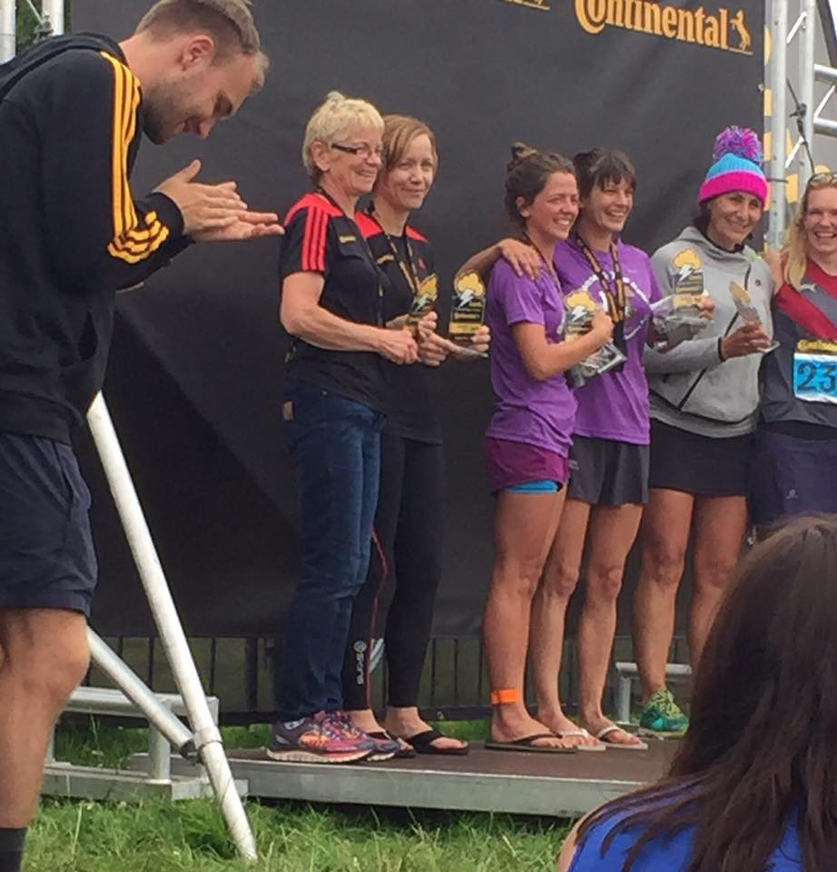

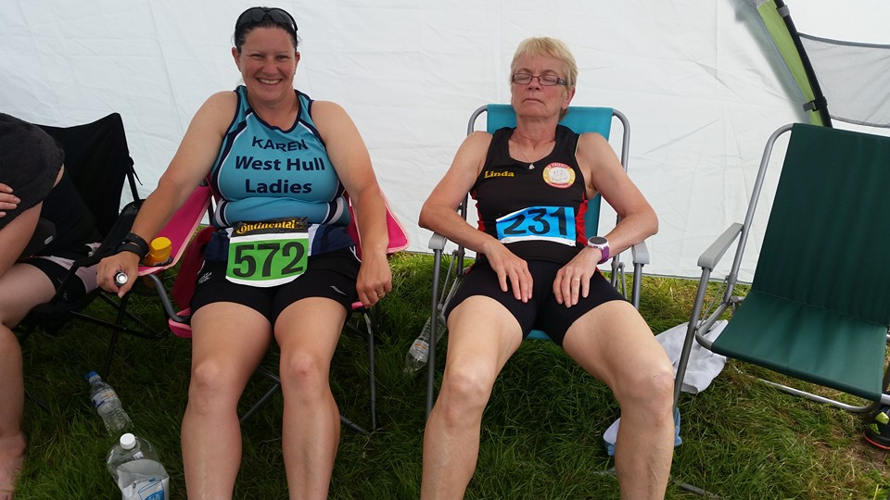

Thunder Run: Amanda
Da Do Run Run at the Thunder Run: Amanda

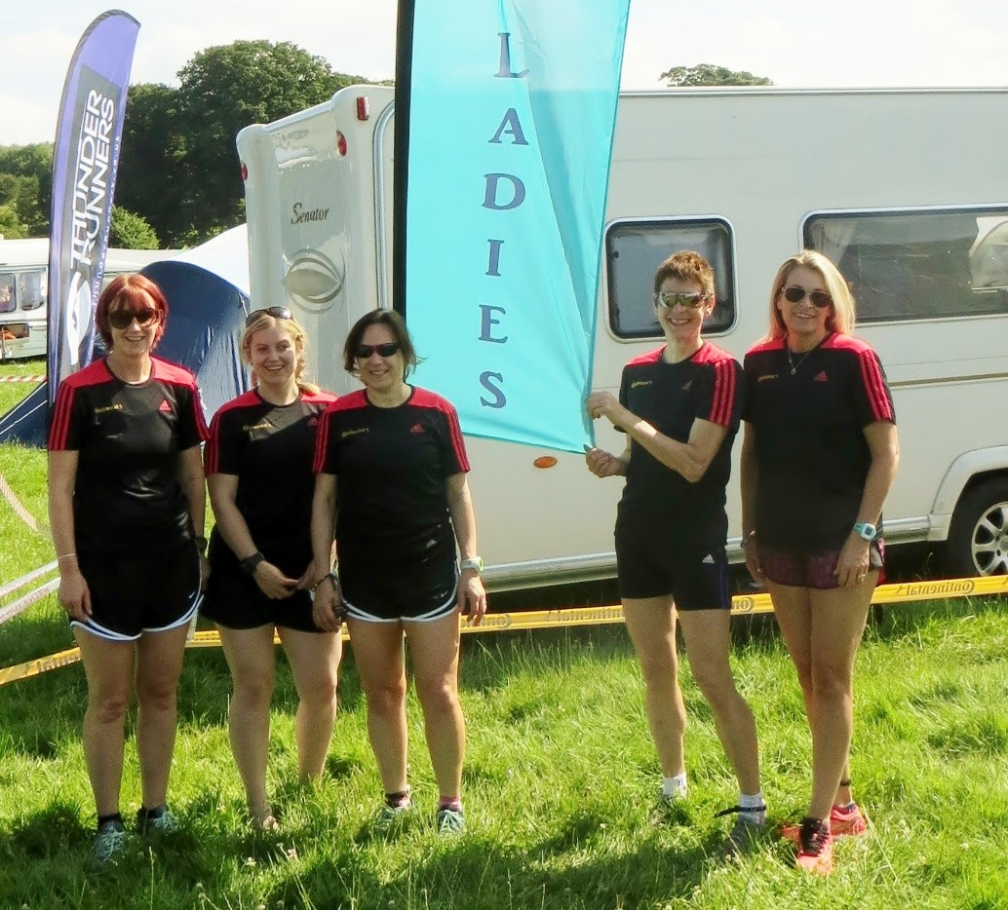
Sara 50K, Sally 40K, Debbie 40K, Amanda 50K, Rach 50K finishing 6th team out of 20

We booked it on a Monday and you know the name
Da do run-run-run, da do run-run
It is the Thunder Run and it's not a game
Da do run-run-run, da do run-run

Chorus
Hey, it could get real rough,
Hey, we'll have to be so tough
But, we’re gonna have some fun
Da do run-run-run, da do run-run

We’ll be running our best through the day and night
Da do run-run-run, da do run-run
and cheering on the podium if we get it right
Da do run-run-run, da do run-run

Chorus
Amanda (Don’t give up your day job!)

This was my first TR24 doing the ‘group thing’. When Verity and I did our pair run 3 years ago it was just us with Neil supporting and Jill, Zoe and Mike came down to see what it was like. Now, thanks to Jill & Zoe, it’s a full on mega camping event, this year with 18 WHL runners, plus Andy and galley slave Paul.
Jill and co got a fantastic position for camping. Not far from the changeover and able to view the runners. Sharing of food and tents made it easy but I liked my little tent to myself to escape briefly.

My experience: It started very hot. Lap 1: 12 noon: I was nervous as I had to push hard to reach the bottle neck before the masses. I did it and was able to keep running for the full lap 50 mins. Nice to hand over. I then had a long break, a good meal with husband before he left, and a lie down in a very hot tent. Lap 2: 9pm was lovely, at first dusky but completely dark by half way. Head torch great. 48mins. Lap 3: 11pm enjoyed it and running well but torch light is ‘flat’ and spoils your rhythm so slower 52 mins. Lap 4: 2am: a little slower but still under 54mins. A lie down before lap 5: 9am finishing with my son and granddaughter cheering me on 53mins. Pleased with my running, thought I would be slower as the route is not easy. As 12 noon approached, headed for the final climb to watch runners finishing their laps which was quite emotional. West Hull Ladies are great cheerers ☺

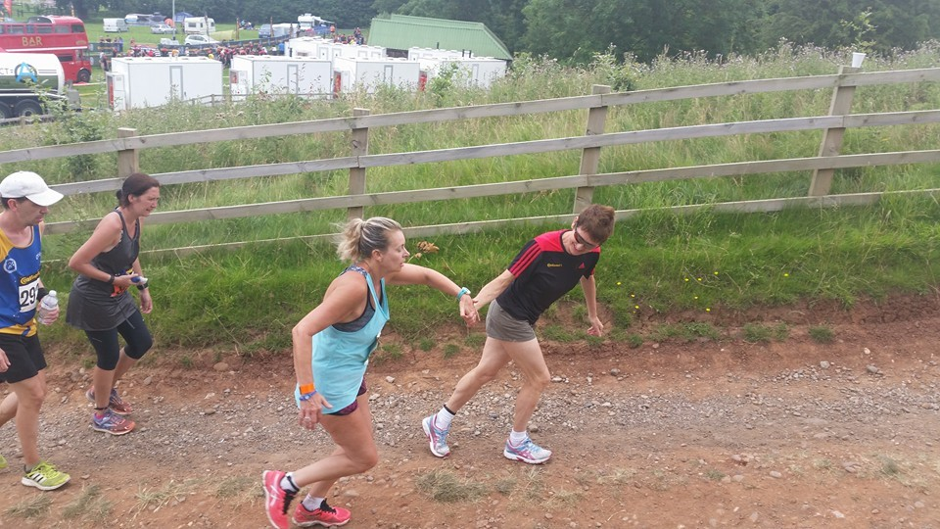
Rach completing her 5th lap – just when she thought she could take a walk ….

Post thoughts from the team

Me: Very tired during the following week. One day I would like to return for a solo run.

Sara: Yes took most of the week to recover, but feel fine now. Rach is on her hols in Italy so she is having a nice recovery. It is Rach trying to convince me that we could do the pairs next year! I have said maybe! I can't say I hated it, I did quite enjoy it and thought it was all very well organised. It was hard, but in an enjoyable way, it felt a good achievement reaching 50k, hats off to Rachel and Linda! See you soon. X

Debbie: My knee is ok fortunately, I did spend most of the week sleeping. Well done to everyone it was a tough route and hot conditions. I am not tempted to consider doing anything like this again, but it was a great experience to be part of such an event.

Sal: I was very tired last week and had lots on with it being my last week of placement & I had friends to stay over at the weekend! I was a little disappointed with not getting a 5th lap, but I did get a huge cold sore last week so I definitely think it was the right decision to stop at 4 and not make myself really ill! Going to do a solo next year!! Just back from a run and feeling a lot better!
Really enjoyed being a part of our team 😊. Sal xx

Walkington ten k : Sharron

Well, yes, I can definitely confirm this is a hilly one! I’ve never done this one before and I couldn’t make any of the recce’s so I was scouring websites and FB for any hint of just how hilly this race was!
I knew about the long incline starting around three quarters of a mile in, lasting til around 2.5 miles. I knew about the couple of ‘bumps’ (hmmmmm – bumps – yeah right!) what I didn’t know about was the MOUNTAIN at around 8k…..!!!!!
Met up with some other WHL before the race, had a photo, went to the loo. Then wandered to the start line.
Felt quite good at the start of this race. Kept the mantra going in my head of ‘don’t start off too quick……..don’t start off too quick’…………I started off too quick. Realising this, I steadied it down a touch. The first incline didn’t bother me too much, everything felt good. I had slowed myself down, I had got myself into a little group, I had my eyes focused on the legs of a chap in front of me (ooo-er missus). He had very noticeable tattoo’s on his legs and this just kept me focused nigh on the whole way round………..ey….come on girls…..stop with the “yeah, yeah’s”…….it was just the tattoo’s……honestly….!!! ;)
I next saw Jane and Cath. It was the way of this race with Jane, we’d keep overtaking each other throughout, it was very reassuring to be looking at WHL vests on route. Tattoo Leg Man was still there too.
There was loads of support everywhere, it was lovely. Everybody clapping and calling your name, saw some ladies from Fitmums who I see at Parkrun so there was a huge cheer from them when they saw me, which made me (inexplicably) jump up and down and cheer madly back at them!
I came upon Diana, a few words of encouragement between us. As I saw Diana we were both running up a particularly nasty hill, my legs just didn’t feel as though they wanted to run up this. Again Jane and I overtook one another. Again, kept Tattoo Leg Man in my sights.
Saw Lynne, she really made me laugh, thanks for the support Lynne.
Then, this mountain at 8k……..I was really happy just before this point. Really happy. I’d gotten over the nasty hill where I saw Diana, in my head I was thinking, that’s it….yipppeeee…..rejoice, rejoice…..flat(ish) from now on………ohhhhh no! Not a chance!
Just before it though, I came upon a lovely down bit, it was glorious! I was closing in on the runner in front but I was thinking, “Hmmmmmm, why isn’t she embracing this lovely downhill?” WHY????? Then I looked ahead, Oh my days……….Who put THAT there???? I caught up to the runner, I had no choice, my legs were going that fast. I said “arhhhh, I can’t slow my legs down,” she laughed her little socks off at me and said “I’m pacing myself for that uphill ahead.” I said, “I couldn’t pace myself if I tried as my legs have a mind of their own at the minute,” she laughed again (I swear she could see steam all around me from the speed my legs were turning) and said “I’m thinking it’s best if I pace myself for it…...” I said “I might as well make use of the mind of their own my legs have got at the moment and get momentum for it” She laughed again, she probably thought that I was going to take off at any minute!!!
So, with no choice in the matter, full steam ahead I went, still spying Tattoo Leg Man ahead.
Boy DID I GO FOR IT???????? DID I EVER!!!!!!!!!!!!!
So, with plenty of “wheeeeeee’s” and “woooo-hoooooo’s” and “wayyyy-hayyyyyys” I motored up to around halfway pretty fast. Then, BOOM there was a point when I swear I just stopped in mid-stride and started going backwards a while, but then Cath caught me up, we had a little chat, which was nice, and got me going forwards again! I had Jane and Cath AND Tattoo Leg Man in my sights ahead which was really comforting.
Didn’t like the end of this race as I kicked for the finish too early, for some reason (probably from being all delirious from the speed my legs got up to on the down the hill before the mountain) I thought the finish line was nearer than it actually was. Where was it??? Coming into the field I saw someone cheering who I knew, she shouted “just round, then round again”, she must have seen the pained and puzzled look on my face to mention this with no prompting at all from me! Saw Sandra cheering, ah nearly there!
Coming towards the finish I saw Jane and Cath ahead…..go Shazza go……let’s finish near them. Didn’t see Tattoo Leg Man unfortunately, which was sad……….
When I got through the finish, I was knackered! I certainly knew tonight I’d run as hard and as fast as I could.
Went to see my time. Oh, I don’t believe it! Only a new 10k PB of 61:14, can’t believe it, so happy!
One happy Shazza went home and filled her face full of cake!!!!
Well done everyone with Walkington, it was a toughie and thanks for all the support.
Sharron

Normanby Duathlon: Amanda

Jill J mentioned that she was doing this Duathlon and after a chat I thought I would take a look. So I checked out the website http://www.curlysathletes.co.uk which emphasised having fun and so decided to go run-cycle-run and I thoroughly enjoyed it. It was lovely to compete without any expectation or pressure in such a beautiful place.

It was a cheap event costing £20 (most duathlons would be double that price). The run was within the grounds of Normanby Hall whilst the cycle route was on very quiet and mostly flat roads.

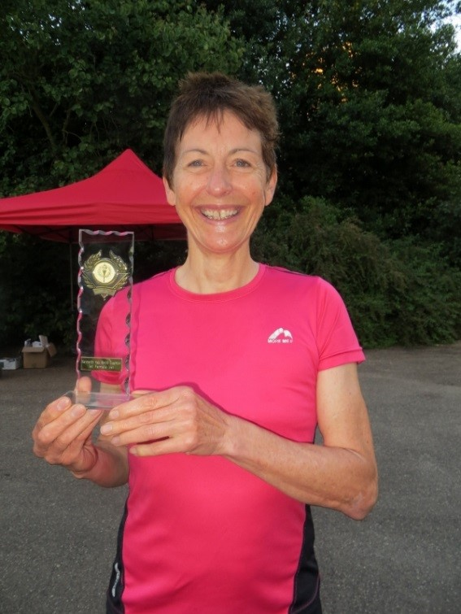
I was pleased with my performance. My 5K averaged 6:53 per mile, my cycle was 19.8mph and the final 2.5K 7:00 per mile.

The first 3 ladies, 1st vet and 1st junior received trophies and as I came 4th lady which gave me the vet trophy. All finishers received an orange boot bag and a large piece of cake.

I was impressed with Jill who chose this event to get her bike out for the first time of the year! I think she was remembering how to clip into the pedals just before the race. Her friend Wayne was also there so nice to have three of us … maybe more next year?

I would really recommend if you want to add a bit of cycling to your running, this is a great event to give it a go. It was really friendly and the last person home got the biggest cheer of all.

Curly Athletes approach:
A collection of amateur and professional athletes, coaches and sport industry experts who feel the world can be a better place through racing and training in multi-sport events. We have a few simple principles to stick to:
- "Athletes before profit" Ensuring every athlete gets value for money and profit can never be our main reason.
- "Race nice", in competitions with your fellow athletes or with the community or businesses we engage with, we’re here to positively influence people.
- ”Everyone is an athlete", we believe anyone who sets themselves a physical goal can call themselves an athlete and we aim to make you feel like one.
- "Have fun", we're not here to take life too seriously!

Burton Constable Ten k : Sharron

Woahh……….This one was SO HARD!!!

I first realised it wasn’t going to be a straight forward one when Rob at Parkrun the day before commented “……….and good luck to those doing the NOTORIOUS Burton Constable 10k…….” WHAT????? NOTORIOUS??????? WHY?????? HUH????? I was stood with Ruth at this point and we both just stared at each other, looking confused, asking those questions…….well, me asking the questions, Ruth was probably trying to stifle a massive GUFFAW aimed my way!!!
So, Nige (who was super supporter) and I turned up to Burton Constable Hall. Very VERY hot day. Lots of countryside……….this 10k was a tale of the three “S’s” – SUN, STRAW and SHEEP…………!!!!!
Saw Diana, had a photo taken, wandered to where the crowds were as we had no idea where the start line was. Saw Kim, then all of a sudden we were off!
I knew it was 2 laps round the estate……if only it was as simple as that……….
I realise now, thinking back that my head broke this run up into sections (running equivalent with miles???)……

First section; SUNSHINE. It seemed to break out just as we started off. We started on gravel, then we all had to bunch up to get through a gate which lead on to a track. I just didn’t know where to run!!! There were a couple of worn track paths but neither seemed comfortable to run on so, I just thought “blow it”, and ran on the grass in the middle of this track. So, first mile went ok, although very hot, the legs felt ok.

Second section; SHEEP. I wasn’t expecting sheep. Turning from the path into a meadow I saw sheep, thought Oh My Goodness, SHEEP!!!! What do I do. Lots of sheep. Do I run really fast and hope they don’t chase me. Do I run steady therefore spending more time in their company. There is a reason I don’t live in the countryside. Anyway, I was bunched in the middle of a group, which eased me a little because I thought if these sheep charge (do sheep charge?) then they’ll get those on the outside before they get to me…….mwhahahaaaa. Not only did I have the sheep to worry about, the ground underfoot was rather uneven and, if you weren’t out in the lead, then there were not many places you could overtake people or indeed run comfortably or stretch your legs. It was grassy, therefore, I used this section to ease down a little as I knew that running in the grass would tire my legs out quicker than normal. This mile was feeling ok too.

Third section; STRAW. Lots of it. I thought as I ran through it “oh, this’ll be nice and soft to land on” it kinda was then, all too soon, it felt as though I was trying to wade through thick snow. My legs seemed to get clumpier and clumpier, as I got further into the field, I felt as though I was running on my knees, how can this be??? Then, we ran through a very narrow opening to run up and over a bridge and through a campsite, which seemed quite surreal really as everyone was going about their normal business, then all of a sudden we were running through the middle of their normal day! Saw Nige at the beginning of the 2nd lap. I won’t tell him this but; he was a very welcome sight, well…..either him or the drinks station he was stood next too, can’t quite decide which I liked more at that point!!! I shouted/moaned/cried to him “ooooh Niiiiige, it’s soooo hard. And I’ve gotta go round and do this agaaaaaain!!!” He shouted back “you can do it, you’re doing well, YOU CAN DO IT!!!!” Was that a little look of ‘ha, daft lass, glad I’M not doing it’ I saw from him as I jogged by, water cups in both hands sloshing all over me…..??!!????

Fourth section; SUNSHINE. A repeat of the first section as the sun was still out as I started back on the gravel towards the track. Felt a little different though, I felt as though I was speeding up. What did they put in that water??? All of a sudden everything felt really good, I was overtaking people, running on the track paths and on the grass in the middle. My legs felt good and I felt as though I could carry on forever, really enjoyed this section.

Fifth section; SHEEP. Gawd, here they are again! Trying to ignore them I started humming to myself. Now, halfway through this meadow there is a gate. To get through the gate there are 2 openings. An opening on the left and an opening on the Right. Hmmmm Left or Right? Going left seemed a swing round whereas right was a straight line there, the easier option. I Kept my eye on the sheep at all times, ha, they weren’t going to creep up on me! Left or Right? Saw sheep wandering to the right entrance, so, easy decision; opted for left. OH……Saw the sheep walking away from the right entrance so aimed for (straight line gate) right, saw the sheep walking back, screamed, so I aimed back to the left gate……The little buggars!!! Then, horror of horrors…….a chap came running up beside me (why me, why????????) clapping his hands to clear the sheep out of the way……….Yeah, all good and well you would think BUT which way where they going to scatter?? OUT to the fields or IN towards the gate……..I stopped humming and started swearing………if those sheep come near me because of him clapping………..I’LL HAVE HIM!!! (That thought lasted way longer than written down there, so you just fill the swear words in at all possible gaps and, also, where there are no gaps!!) So, I got through the gate without the sheep thinking of me as their dinner(!) and remembering the uneven ground took it really steady, which wasn’t too hard to do as I was tiring a little from the warmth, I was still able though, to keep going. I hadn’t needed to stop yet and this positive thought carried me on, as I knew I was nearing the finish.

Sixth section; STRAW. Hit the straw section again, now aware of its amazing energy zapping capabilities I emerged from this section relatively unscathed. Another lady and I happened to start running side by side and we just started chatting, about nothing really. We helped each other through this section so it wasn’t as bad as the first time round. Although tired, my legs were still moving. Through the campsite again, normal life going on. I quite liked the bit after the campsite so stepped it up a little.

Nearing the end, with around 200/300 metres or so to go, I heard supporters cheering on a lady just behind me. I could hear her. I had the little selfish thought then of “She aint getting by me, they can cheer all they like for her, she aint getting by me” I saw Nige, I saw the water station, I heard the cheers for the lady behind and my legs just seemed to widen their stride and off they kicked for the finish, it felt really good, it felt as though I was flying there…… J
The finish, yay! Need water……..saw Kim, we had a sweaty hug. Saw Diana in the queue for the t-shirts, another sweaty hug.
That was a very hard 10k today. Glad I’ve done it. Glad I’ve got the t-shirt. Glad I had nothing planned for the rest of the day, to give my legs the rest they well and truly deserved!!!
Well done to Kim and Diana, was lovely to see you both.
Sharron

General Training Advice (especially for our newer ladies)
Amanda (coach for West Hull Ladies)

Number one is always enjoy your running. It’s hard to improve if it is no fun, if you enjoy it you will keep coming back for more. Good company, variety and achievable distances and pace for you are essential and (believe it or not) occasionally going out of your comfort zone will make it a joy to run.

Building your training
Your foundation is the number of miles you run per week and building this is your first priority. It is recommended you run at least 3 times a week and aim for at least 12 miles, building up gradually.
The second is your long endurance run. It is recommended that your long run is restricted to approximately 3 times your daily average whilst you are building up. This avoids overuse injuries. E.g. If you run 14 miles per week your daily average is 2 miles so your long run should be around 6 miles.
Together the foundation and long run adapt and strengthen your body, improve your lungs and they physically change your body by building muscle, increasing lung capacity and even creating more blood capillaries.
Third is speed work e.g. intervals, fartlek, hill reps, threshold runs. Caution is recommended for those who have not built a good base as the forces you put on your legs are a lot higher than steady running. But, once you have your foundation, this is what will improve your speed most by improving your lungs and your strength. It’s also a lot of fun.
As a club we do very little threshold training because it is difficult to do with a mixed ability group. However this is a very much recommended training session for improvement. You run for at least 5 mins at a level where you cannot have a conversation, maybe throw a few words out. But, this means that the group becomes very spread out. A parkrun is a good threshold training session. Or if you have a friend of similar pace who is willing to be a training partner that would work too.

Targets and Training plans
If you have a race target it is very useful to find a training plan. It keeps you going because it tells you what to do and you can tick the training off each week and give yourself a pat on the back. If your challenge is daunting you can check out the training for the coming week and think “yes I can do that” without having to think about the final challenge. Then, step by step the training gets you there.
When you find your training plan don’t be worried about moving the runs about to fit your life schedule. It’s important to keep the essence of the training i.e. the number of miles each week, the longest run and the quality runs but, for example, if it says 5 mile run on Tuesday night but that’s when you take the kids swimming, move it to another night.
To get training plans go Google. For example ‘run training plan 10K sub 60 mins’. If you find a few see which you think looks doable for you and what you prefer. I like distances, some like time e.g. I like run 5 miles, some like run for 45 mins.
Running Fuel: Recipe Corner

Super tasty quinoa meal: Jermaine

I went on a lovely walk in Dalby Forest with Shell today and as I knew she was running with the marathoners I thought it would be nice to make a picnic style lunch. I also wanted to use up a load of stuff I had in the fridge before going to Greece.
The recipe I want to share was a quinoa recipe I made which can be eaten as a salad. Its for 2 people (just increase quantities for more). This can be vegan or vegetarian you could add chorizo for a meat dish.

Ingredients:
50 g quinoa
a handful of walnuts
1 small apple
a handful of sultanas
a small courgette
half a red onion
2 cloves of garlic
a handful of seed mix (sesame, linseed, pumpkin & sunflower seeds)
1 stock cube (vegetable)
either a knob of butter or a glug of olive oil
150 ml water
Method:
- Boil the water & add the stock cube.
- Rinse and drain the quinoa add to the boiling stock then turn the heat down an simmer (approx 20 mins).
- While this is boiling.
- Chop the onion, garlic and courgette fry in a pan on medium heat until the onion is glazed and the courgette is cooked.
- Once the quinoa is cooked take it off the heat and leave for approx 10 mins then add a glug of olive oil or the butter and fluff it up.
- To this you add the cooked courgette, onion & garlic and stir.
- Then chop the apple into small cubes.
- Crush the walnuts and add them with the sultanas and the seed mix all together give it a good stir and season as you like (I didn't need to add any seasoning).

This is fairly high in protein and packed with goodness - hope you enjoy - Jermaine x

Key Lime Pie: Jermaine

( courtesy of BBC Good Food)
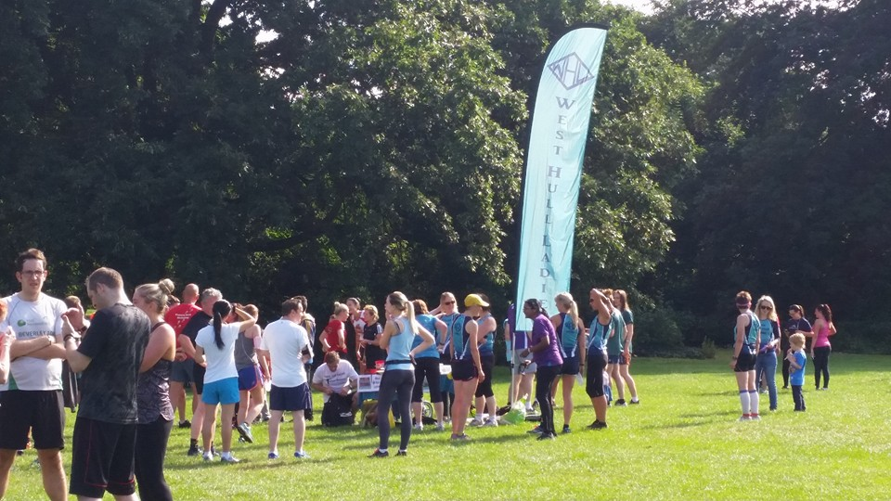
and recommended by parkrun tourist Steve.
" thanks Hull for a great run, friendly atmosphere and a piece of key lime pie that was absolutely delicious. "
Steve B. from Worcester.
Ingredients:

- 300g Hob Nobs
- 150g butter
- 1 x 397g tin condensed milk (we used Nestlé)
- 3 medium egg yolk
- finely grated zest and juice of 4 limes
- 300ml double cream
- 1 tbsp icing sugar
- extra lime zest, to decorate

Method:
- Heat the oven to 160C/fan 140C/gas 3. Whizz the biscuits to crumbs in a food processor (or put in a strong plastic bag and bash with a rolling pin). Mix with the melted butter and press into the base and up the sides of a 22cm loose-based tart tin. Bake in the oven for 10 minutes. Remove and cool.
- Put the egg yolks in a large bowl and whisk for a minute with electric beaters. Add the condensed milk and whisk for 3 minutes then add the zest and juice and whisk again for 3 minutes. Pour the filling into the cooled base then put back in the oven for 15 minutes. Cool then chill for at least 3 hours or overnight if you like.
- When you are ready to serve, carefully remove the pie from the tin and put on a serving plate. To decorate, softly whip together the cream and icing sugar. Dollop or pipe the cream onto the top of the pie and finish with extra lime zest.

Breakfast Smoothie: Linda
Some of us have been suffering from summer colds that have hung on for longer than we would have liked. Have left us feeling tired and weak making it difficult for us to get back on track with our training. Some have had horrid chest infections that have been slow to get rid of too. Here is a breakfast smoothie receipt that will help put back some nutrition into our bodies and help to fight off the bugs.
Below is just a guide, I have used the Alpro almond or coconut milk alternative. I have used a variety of fresh and even tinned fruit so whatever you like really. But it must have the magic fresh ginger in and I love ginger so I put in around a 2” piece plus the honey.
Whizz up in a blender, it’s yummy.

Ingredients:
400ml Milk
250g Greek Yoghurt
40g Wheatgerm or Oatmeal
240g frozen fruit (I love Mango but you can use any fruit)
A good piece of fresh Ginger
3 dessert spoons of runny honey
50g Almonds

2016 RACE DIARY

Free 5K time trial every Saturday 9am:
Hull Parkrun Peter Pan Parkrun Humber Bridge parkrun

Double check dates, times and entry fees with the official website or the entry form. Zx Website contains all the links to the races: http://westhullladies.org.uk/races.htm

August 2016
 | 7th/09:30 | Jane Tomlinson York 10K | £25.82 UKA/£27.96 | Online entries only | Online entry
 | 21st/11:00 | Escrick 10K | £13 UKA/£15 | Entry form | Online entry (+£1.70)
September 2016
 | 4th/10:00 | Major Stone Half Marathon | £18.70 UKA/£20.70 | Online entries only | Online entry
 | 4th/11:00 | Tholthorpe 10K | £10 UKA/£12 | Entry form | Online entry (+£1.40)
 | 4th/10:15 | City of Salford 10K | £13 UKA/£15 | Online entries only | Online entry
 | 11th/09:30 | Vale of York Half Marathon | £21 UKA/£24 | Online entries only | Online entry
 | 11th/TBC | Great North Run | Race full | Race full | Race full
 | 11th/10:30 | The East Coast Classic 10K | £10 UKA/£12 | Online entries only | Online entry
 | 11th/11:00 | Shepley 10K | £10 UKA/£12 | Online entries only | Online entry
 | 18th/10:30 | The Tadcaster 10 Mile | £16 UKA/£18 | Online entries only | Online entry
 | 18th/09:00 | Hull Marathon | £40 UKA/£42 | Online entries only | Online entry
 | 25th/10:00 | Isle of Axholme Half Marathon | £20 UKA/£22 | Online entries only | Online entry
 | 25th/11:00 | Bishop Burton College Canter 7 Miles | £10 UKA/£12 | Online entries only | Online entry
 | 25th/09:30 | Ikano Robin Hood Marathon | £40 UKA/£45 | Online entries only | Online entry
 | 25th/09:30 | Ikano Robin Hood Half Marathon | £31.75 UKA/£36.75 | Online entries only | Online entry
October 2016
 | 1st/16:00 | Bournemouth Supersonic 10K | £24.50 UKA/£26.50 | Online entries only | Online entry (+£2.08)
 | 2nd/08:00 | Bournemouth Half Marathon | £30.50 UKA/£32.50 | Online entries only | Online entry (+£2.08)
 | 2nd/10:00 | Bournemouth Marathon | £50.50 UKA/£52.50 | Online entries only | Online entry (+£2.08)
 | 15th/11:00 | Gruesome Twosome Half Marathon | £20 UKA/£23 | Entry form | Postal entries only
 | 15th/10:30 | Gruesome Twosome 10K | £13 UKA/£16 | Entry form | Postal entries only
 | 16th/10:00 | Bridlington Half Marathon | £15.50 UKA/£17.50 | Entry form | Online entry
 | 30th/10:00 | Yorkshire Coast 10K | £15 UKA/£17 | Online entries only | Online entry opens 1st June, 7am
November 2016
 | 6th/TBC | Deep Dale Dash | £15 UKA/£17 | Online entries only | Online entry
 | 6th/10:30 | Guy Fawkes 10 Mile | £14 UKA/£16 | Online entries only | Online entry
 | 6th/09:30 | Leeds Abbey Dash | £22 UKA/£24 | Online entries only | Online entry opens in June
 | 13th/11:00 | Dalby Dash 10K | £13.70 UKA/£15.70 | Online entries only | Online entry

NOTE: Club Vests must be worn at any races you enter
under the West Hull Ladies running club name.
Kit Order Form

NEW STYLE VESTS and HOODIES are purchased direct from www.pbteamwear.co.uk
On website: click on Clubs, Athletics Club, West Hull Ladies RC
Pick your size, name you wish to have on the front and follow payment instructions

For all other purchases use this form.

FORENAME ___________________________________
SURNAME ___________________________________

ORDER - tick what you require and circle your size Price
- OLD STYLE VEST SIZE 10 £15.00 £5.00 (useful for training)
- LONG SLEEVED SIZE 12 14 £18.50 £10.00 (useful for training)

- BEANIE HAT £6.50
- PINLESS WHL NUMBER FASTENERS (set of 4) £3.00

DATE Ordered _______________
AMOUNT PAID _______________

Please transfer payments online with your name and marked as ‘Kit’ to:
Account: 63762742 Sort Code: 20 43 49

Or cheque payable to ‘West Hull Ladies RRC’, and write your name and ‘Kit’ on the back and give to Club Treasurer Linda Dodsworth, 110 The Stray, South Cave, E Yorkshire. HU15 2AL

Sign on receipt of goods _________________________________
DATE _______________

Please complete this form and email to diazmaria@btinternet.com
Thanks.
Maria Kit Officer

